|  |  |  |
| --- | --- | --- |
| **Project Title** | **:** | **A CRM APPLICATION FOR WHOLESALE RICE MILL** |

## Overview:

The **Rice Mill CRM Application** is a comprehensive solution tailored to streamline and enhance the operations of rice mills. This application focuses on providing daily reporting on rice production, sales, and type-wise breakdowns, ensuring that owners receive detailed and actionable insights. By leveraging Customer Relationship Management (CRM) principles, the application enhances customer interactions, optimizes factory operations, and boosts overall efficiency.

**Project Description:**

Salesforce is a versatile customer success platform designed to assist organizations in managing sales, services, marketing, and analytics while connecting with customers efficiently. With Salesforce, businesses can operate from anywhere, leveraging standard products and features to manage relationships with prospects, customers, employees, and partners. The platform stores data securely in the cloud and offers seamless collaboration. The steps involved in building a CRM application for a wholesale rice mill project using Salesforce include creating a developer account, designing custom objects like Supplier, Consumer, RiceMill, and Rice Details, and creating custom tabs. Users can also create a Lightning App, define fields for the objects, and set up page layouts for the app. The next steps include creating profiles, assigning roles using the role hierarchy, giving permission sets, and generating reports. The project also involves creating dashboards, writing Apex classes and triggers, and building Master-Detail and Rollup Summary fields to manage data effectively. The entire project is designed to streamline operations, simplify data management, and improve organizational efficiency through automation and detailed analytics.

**Features and Functionality:**

**1.creating developer account and Activate account:**

By signup option in salesforce platform we create developer account and activate account by verifying through mail.

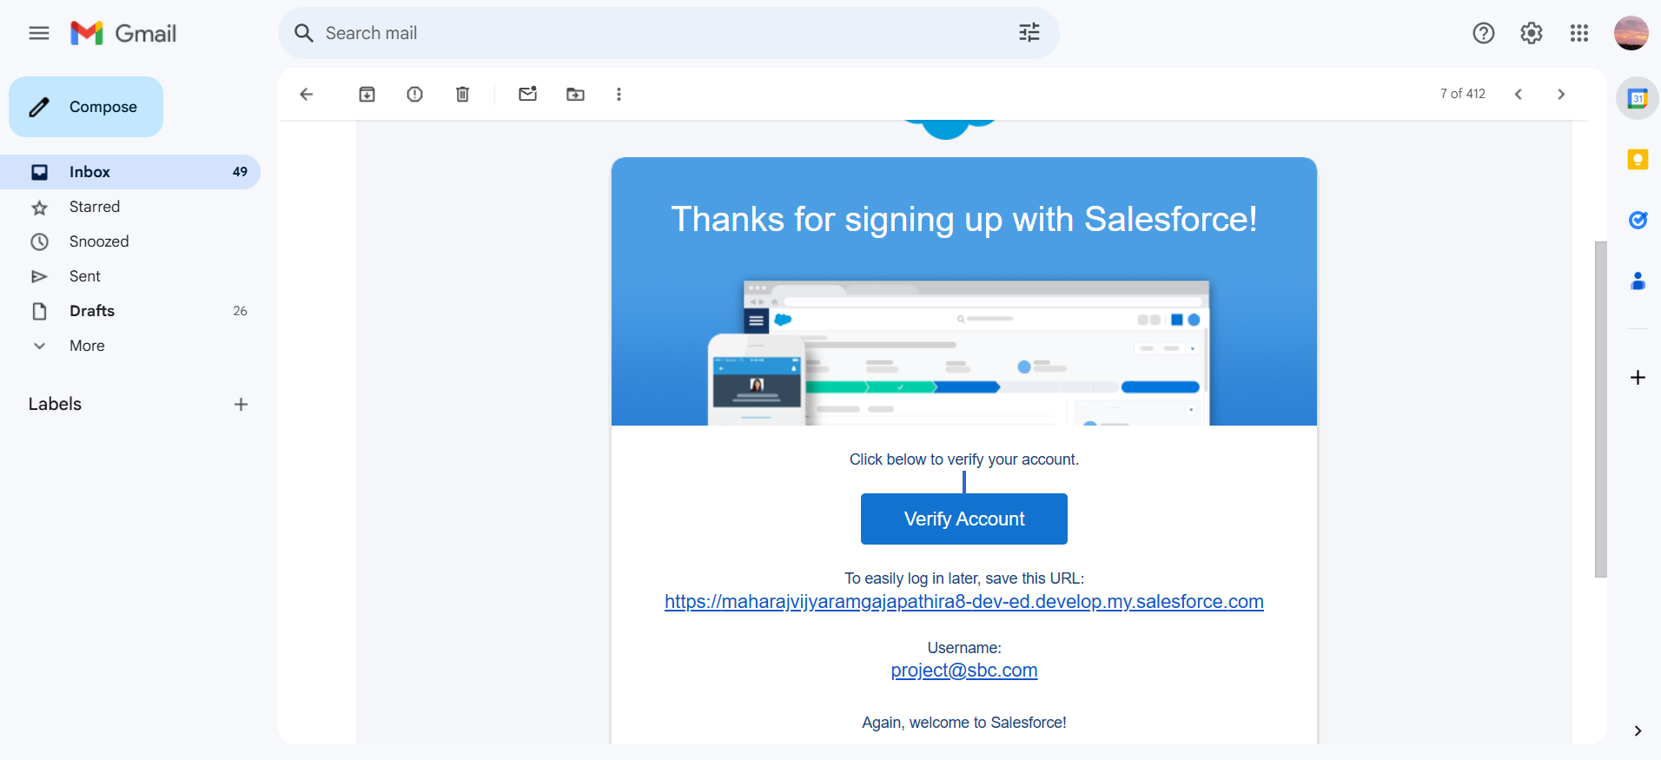

**2.creating objects(Supplier,Consumer,RiceMill,Rice Details):**

Salesforce objects are database tables that permit you to store data that is specific to an organization. What are the types of Salesforce objects

Salesforce objects are of two types:

1.Standard Objects: Standard objects are the kind of objects that are provided by salesforce.com such as users, contracts, reports, dashboards, etc.

2.Custom Objects:Custom objects are those objects that are created by users. They supply information that is unique and essential to their organization. They are the heart of any application and provide a structure for sharing data.

To create an object:

From the setup page >> Click on Object Manager>> Click on Create>>Click on Custom Object.

**supplier object:**

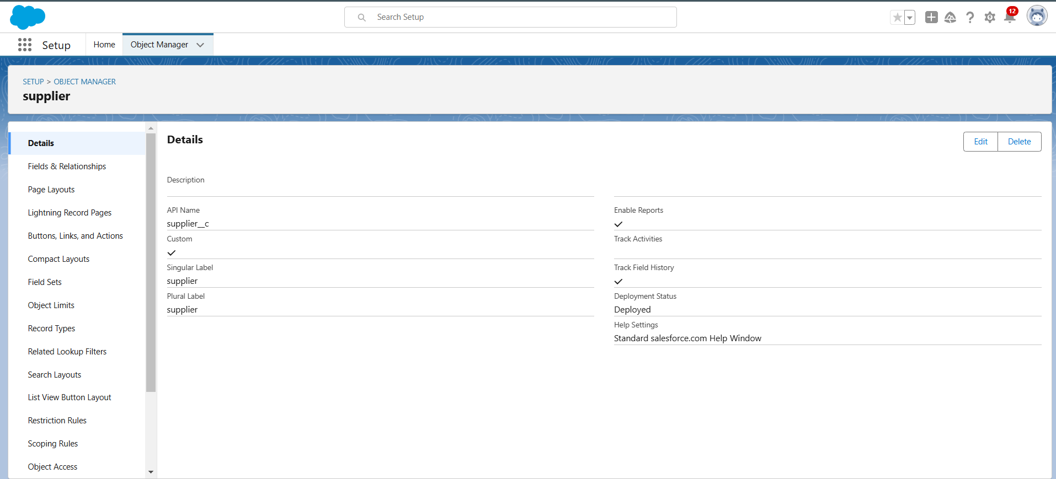**Consumer object:**

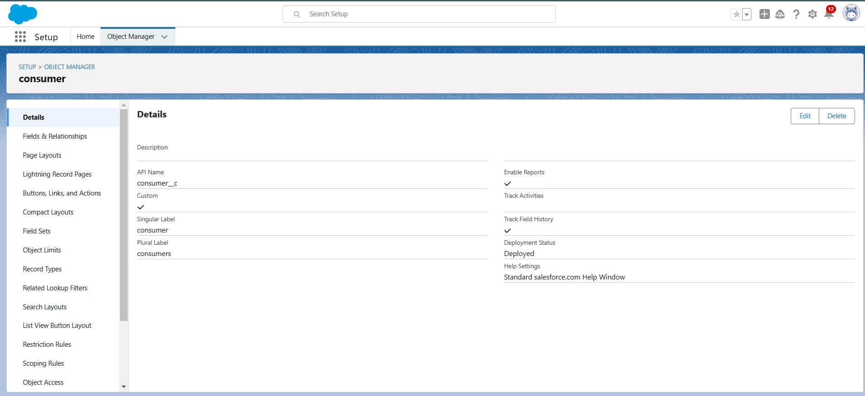

**Rice mill object:**

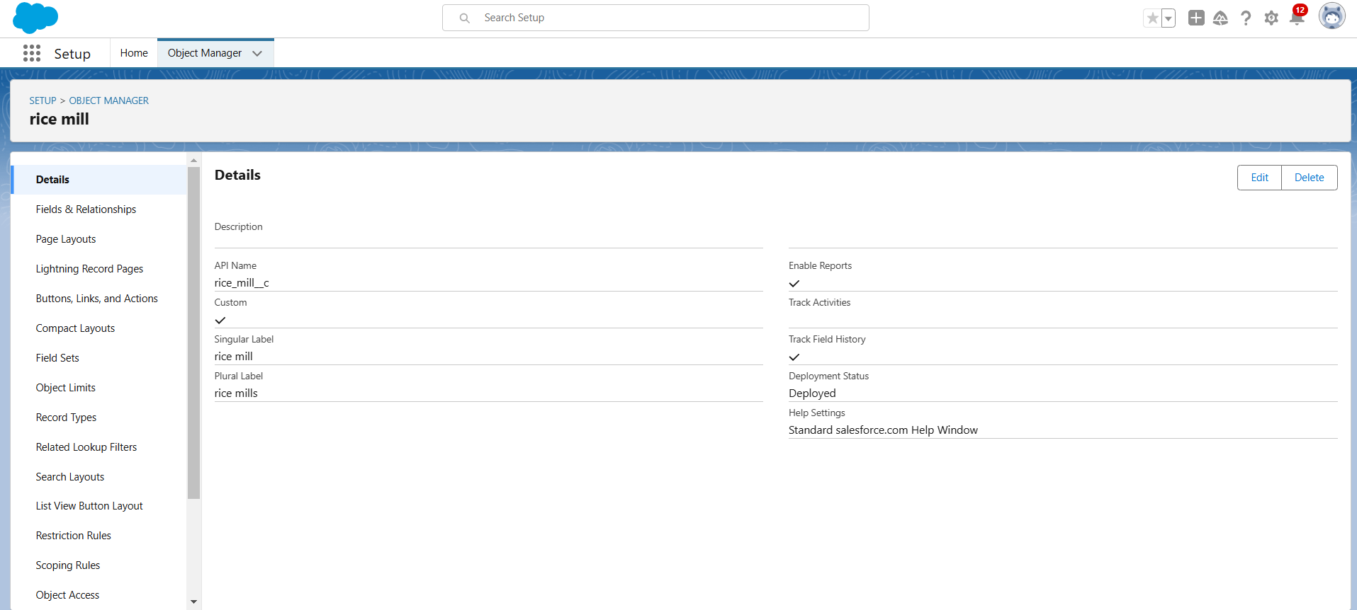

**Rice details object:**

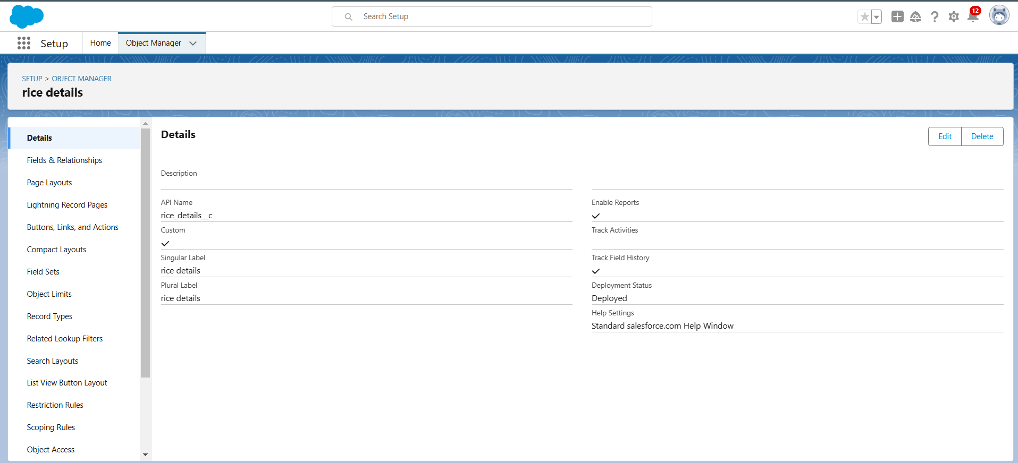

**3. Create Custom Tabs:**

A tab is like a user interface that is used to build records for objects and to view the records in the objects.

Custom Tabs:

Custom object tabs are the user interface for custom applications that you build in salesforce.com. They look and behave like standard salesforce.com tabs such as accounts, contacts, and opportunities.

Add tabs for the custom objects like Supplier and RiceMill for easy access.

**created custom tabs:**

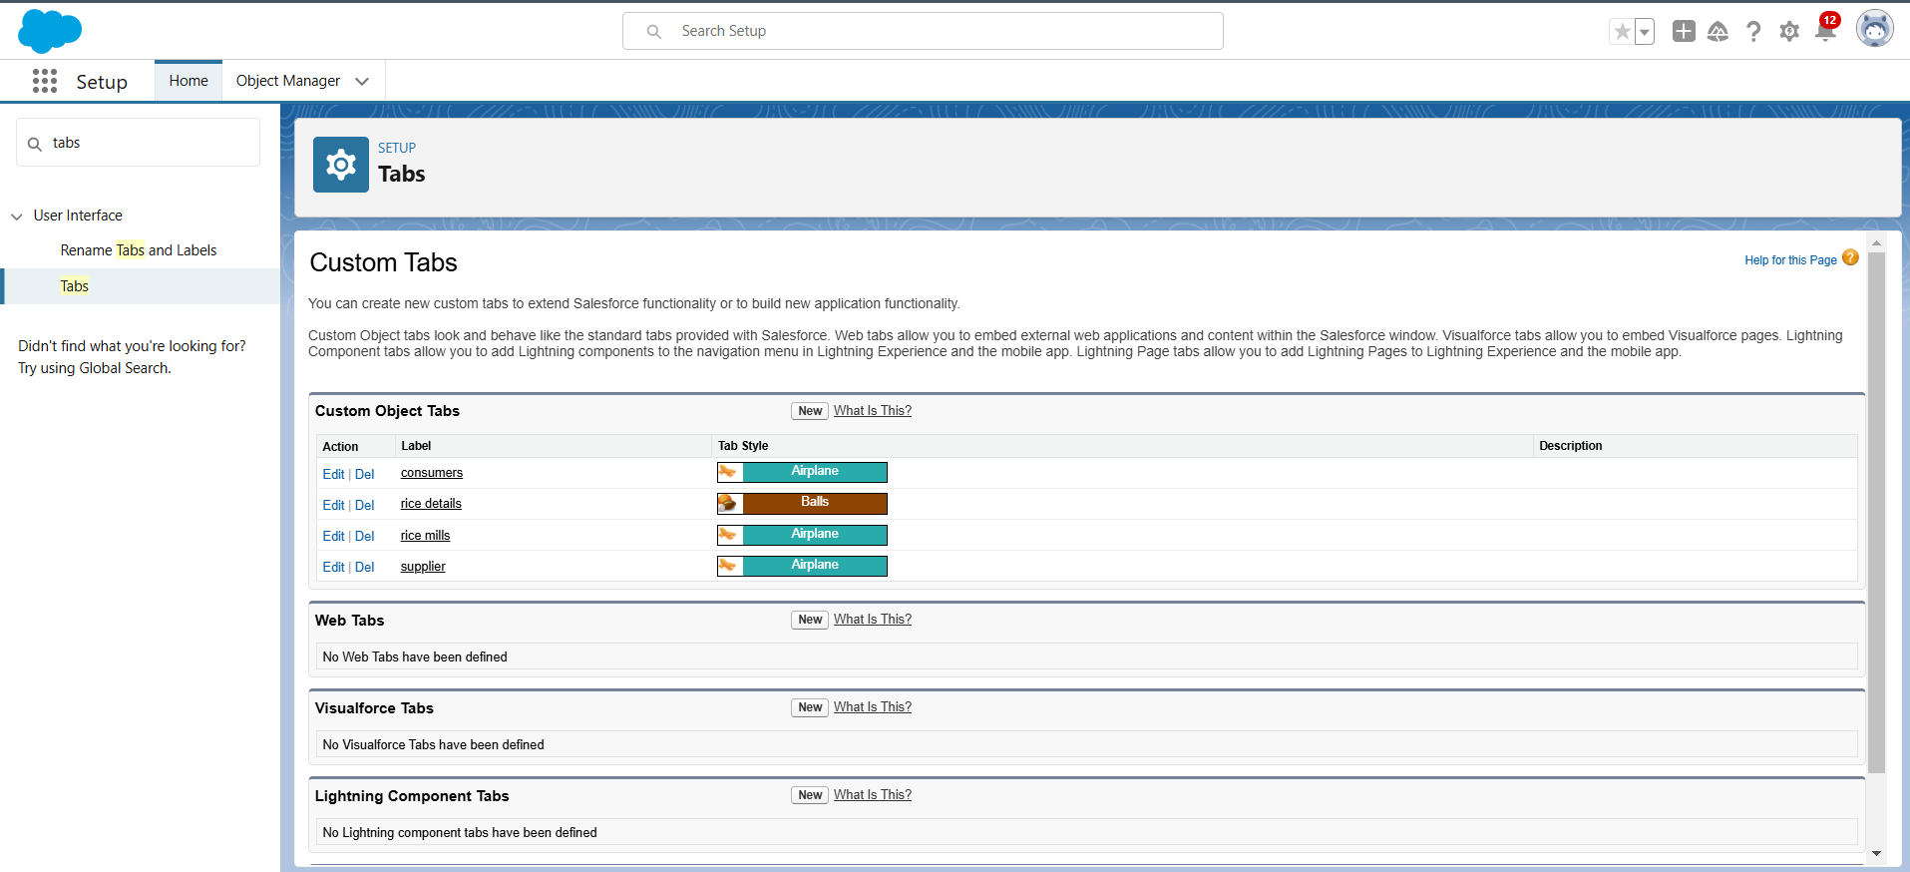

**4. The Lightning App Creation**

An app is a collection of items that work together to serve a particular function. In Lightning Experience, Lightning apps give your users access to sets of objects, tabs, and other items all in one convenient bundle in the navigation bar.

Build a lightning app to integrate your custom objects. Customize with your logo and color scheme, and add navigation items.

**creating a lighting app:**

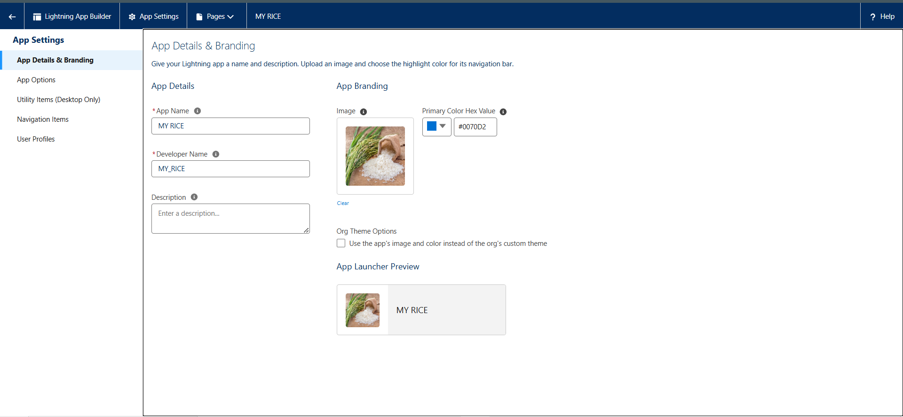

**Default options:**

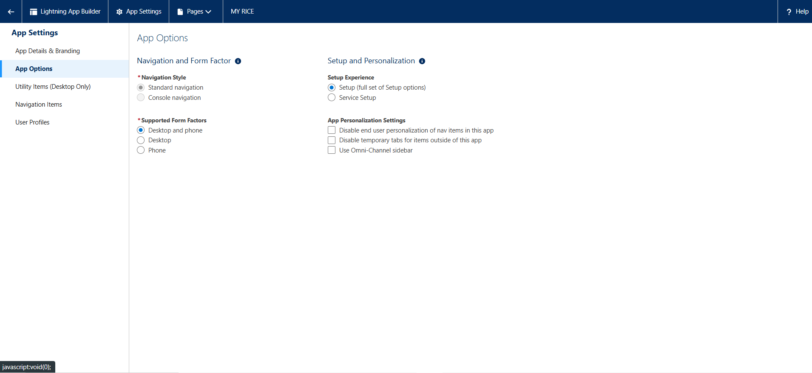

**Navigation items:**

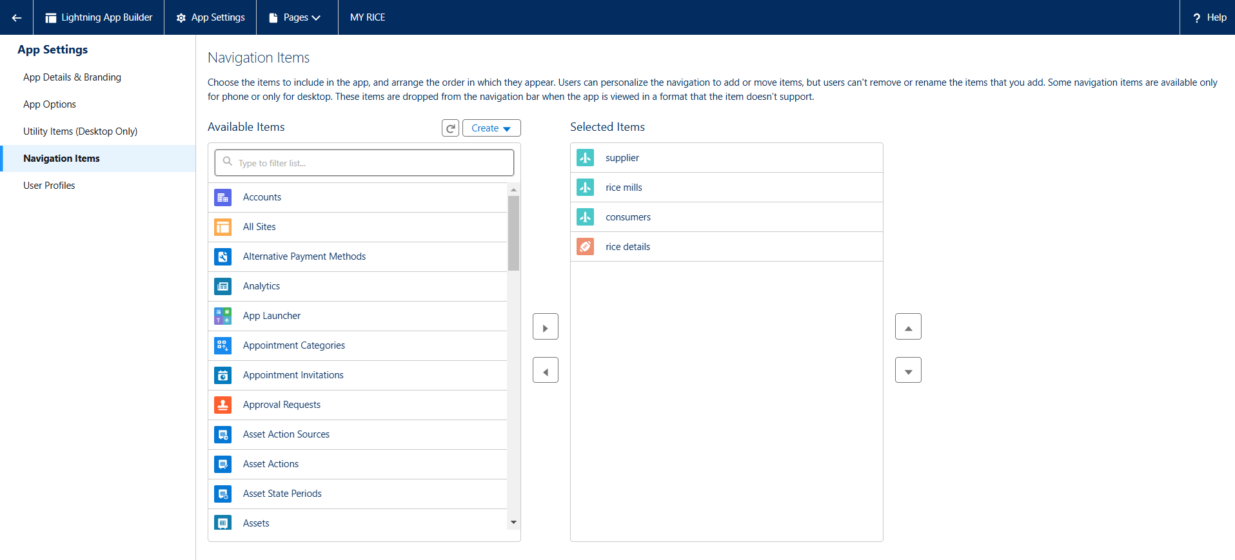

**5. Creating Fields for Objects :**

Fields represent the data stored in the columns of a relational database. It can also hold any valuable information that you require for a specific object. Hence, the overall searching, deletion, and editing of the records become simpler and quicker.

**Standard Fields:** As the name suggests, the Standard Fields are the predefined fields in Salesforce that perform a standard task. have some fields that you will find common in every Salesforce application.

They are,

1. Created By

2. Owner

3. Last Modified

4. Field Made During object Creation

**Created fields in consumer object:**

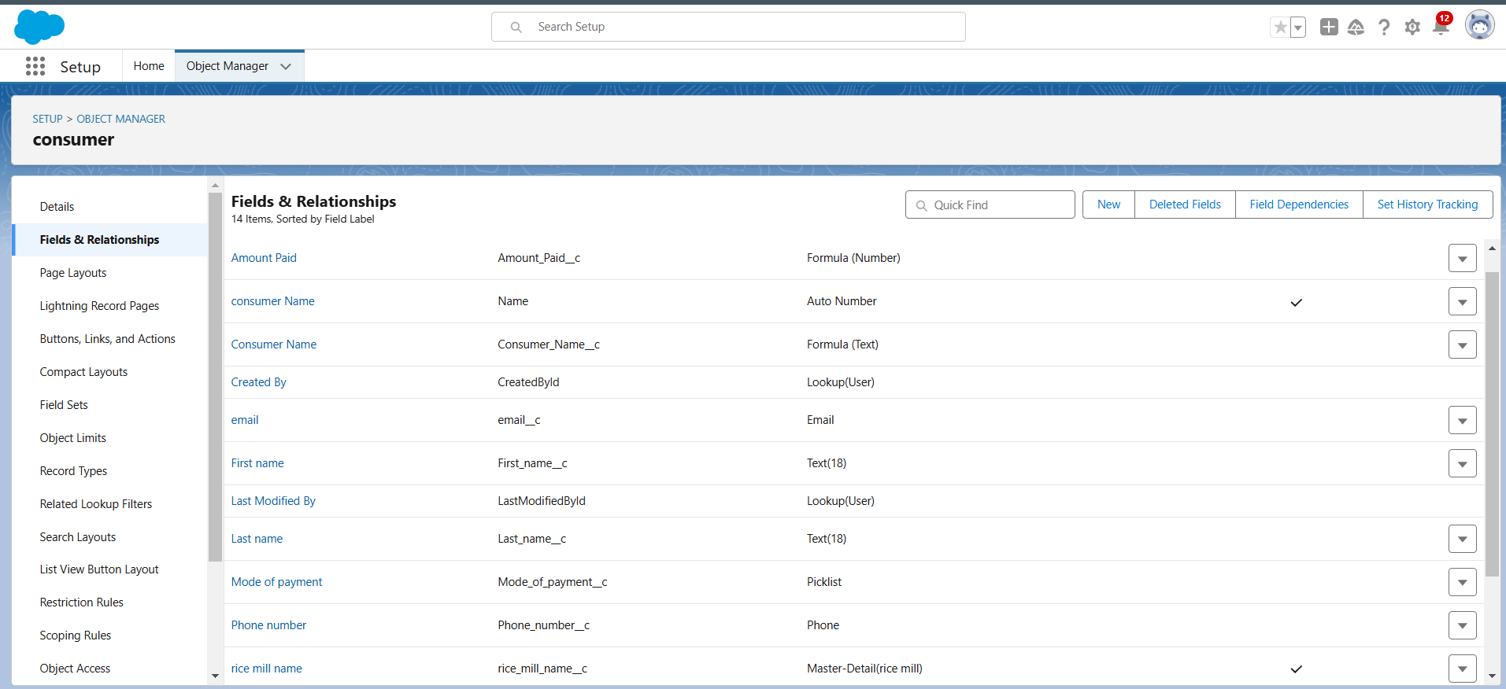

**Created fields in supplier object:**

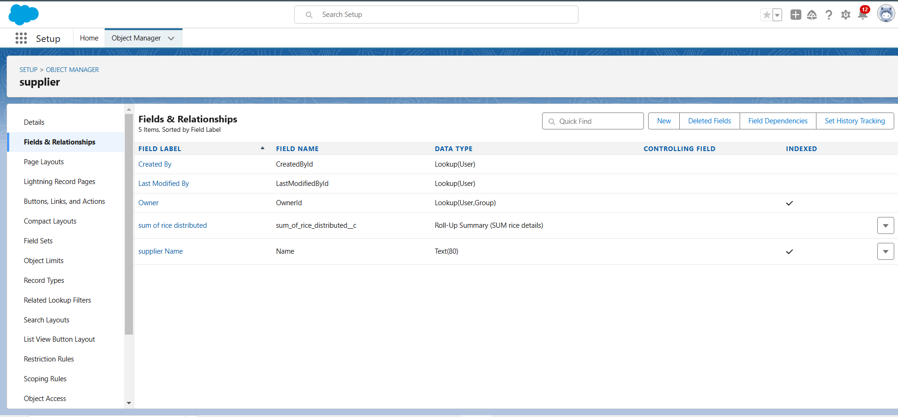

**Created fields in rice mill object:**

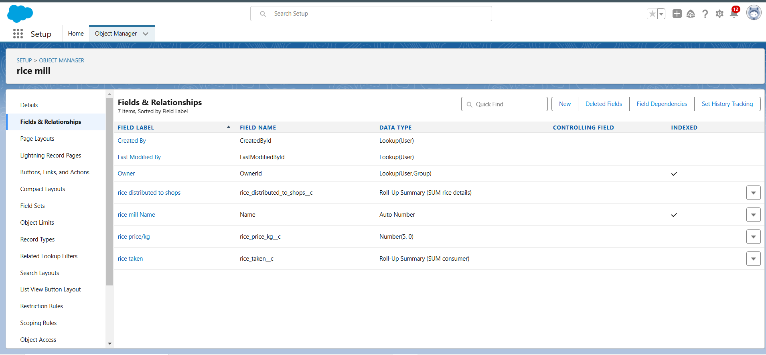

**Created fields in rice details object:**

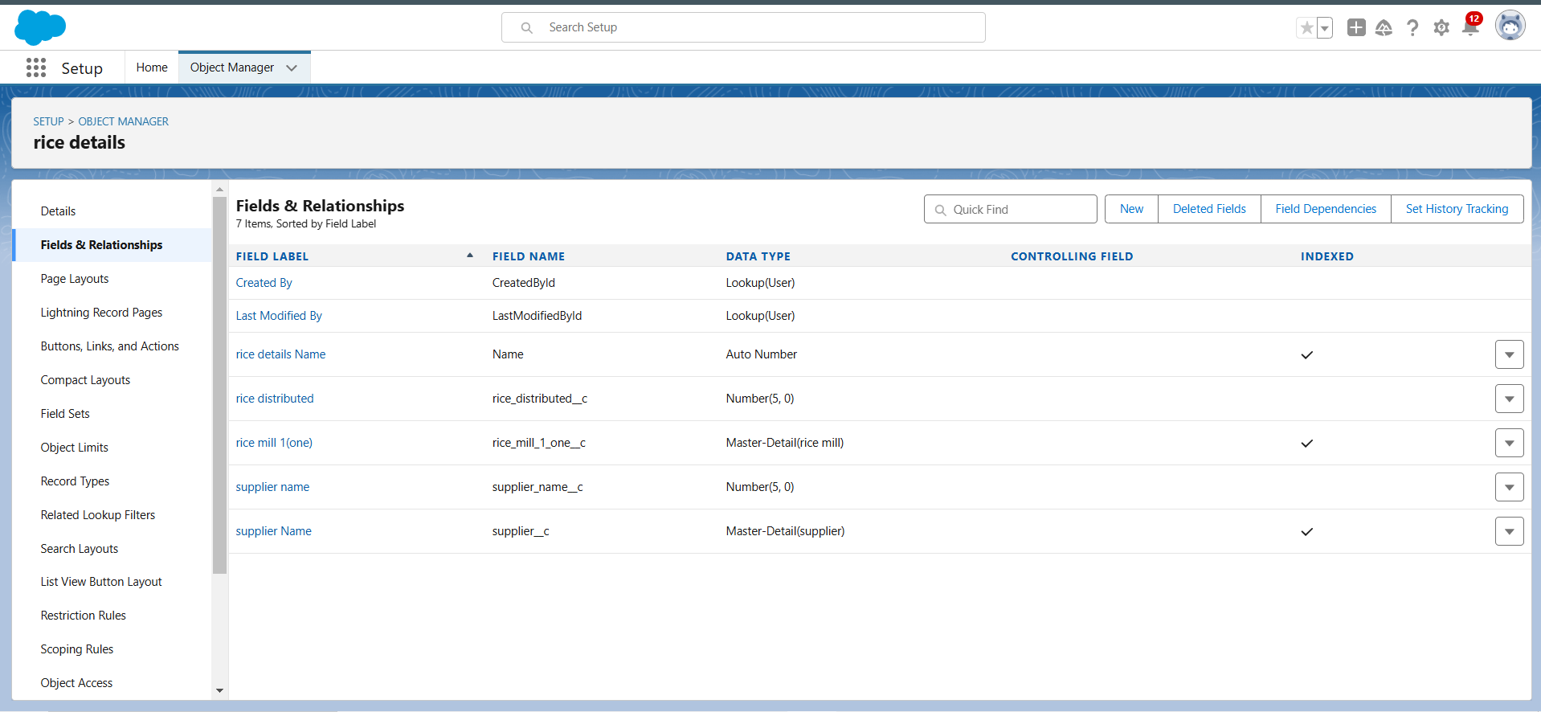

**6. Page Layout :**

Page Layout in Salesforce allows us to customize the design and organize detail and edit pages of records in Salesforce. Page layouts can be used to control the appearance of fields, related lists, and custom links on standard and custom objects' detail and edit pages.

Created and customized page layouts for objects like Consumer and RiceMill. Divide fields into sections like "Personal Details" and "Rice Details."

**Page layout:**

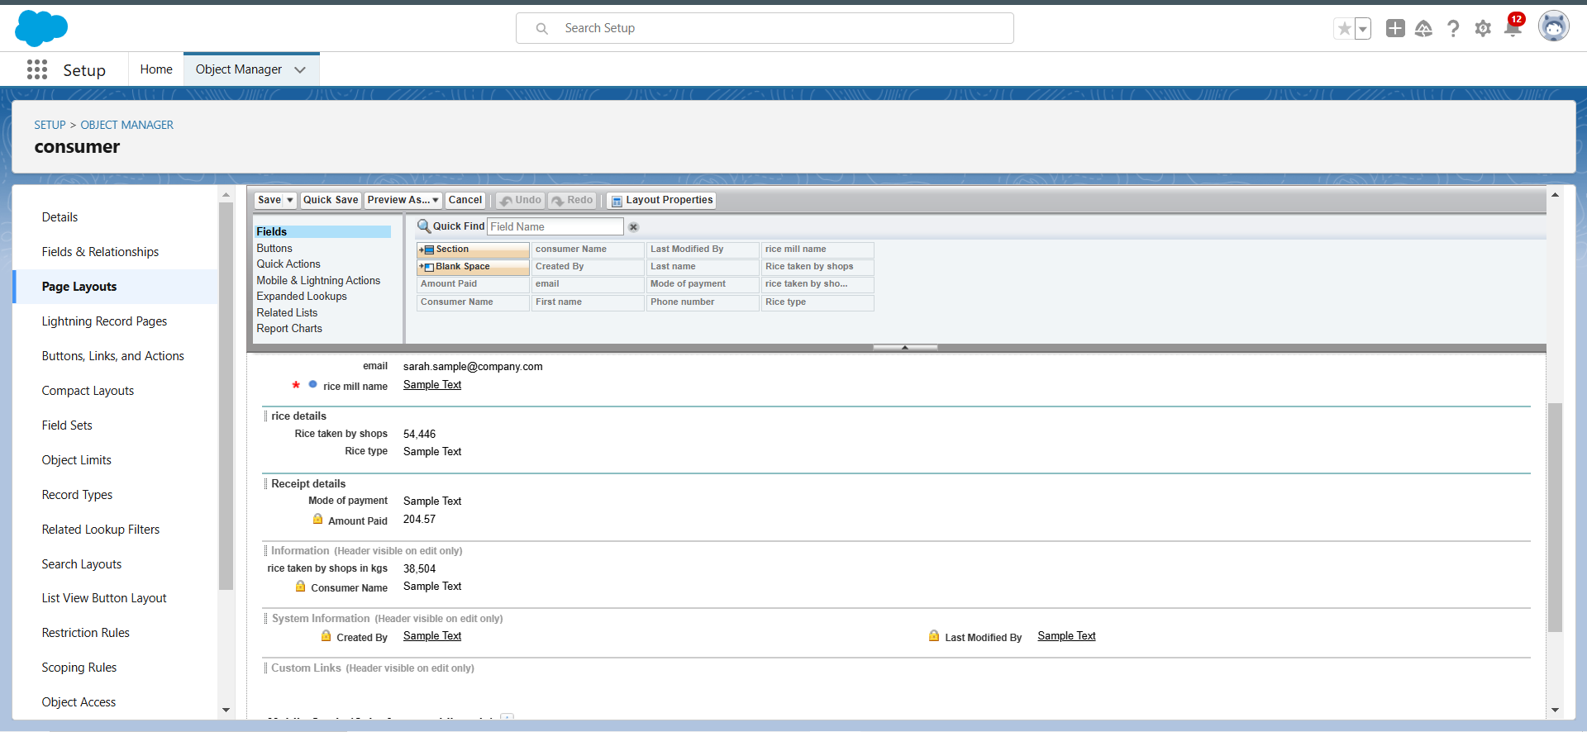

**7. Creating Profiles :**

A profile is a group/collection of settings and permissions that define what a user can do in salesforce. Profile controls “Object permissions, Field permissions, User permissions, Tab settings, App settings, Apex class access, Visualforce page access, Page layouts, Record Types, Login hours & Login IP ranges. You can define profiles by the user's job function

Profiles define the permissions users have in the system. Clone and customize profiles for roles like Owner, Employer, and Worker**.**

**Owner profile:**

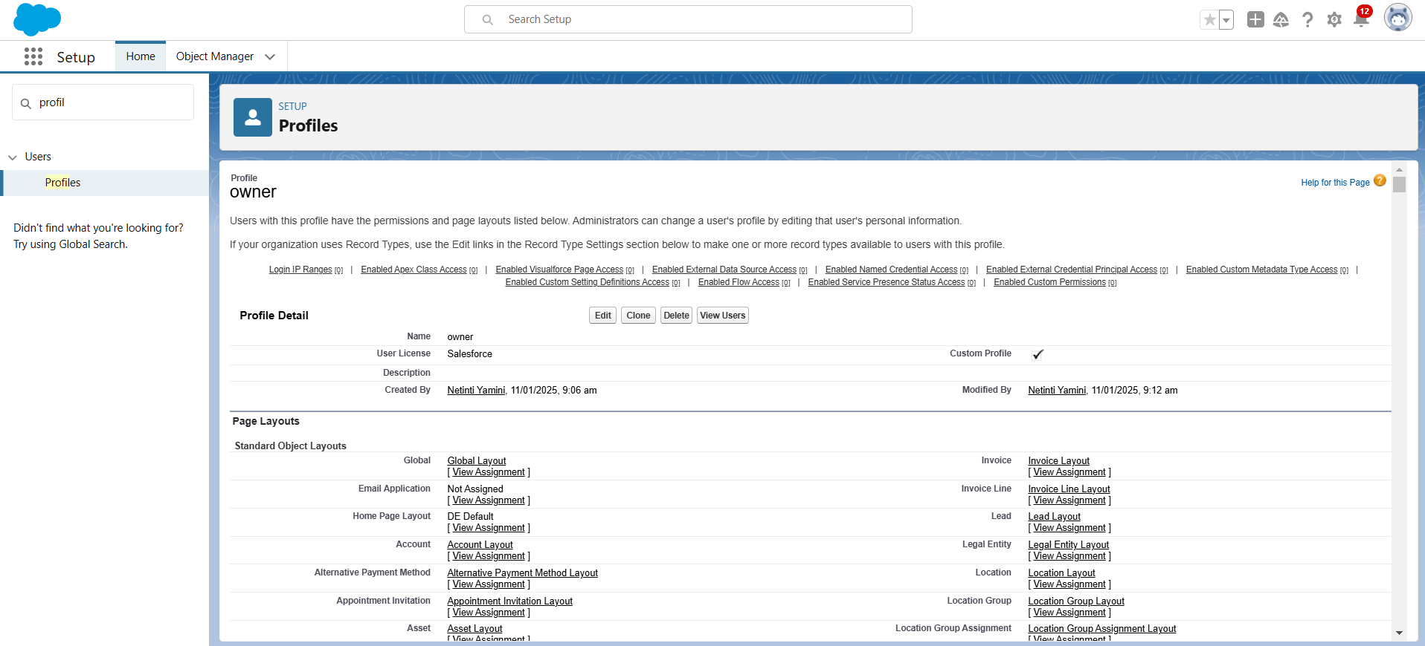

**Employer profile:**

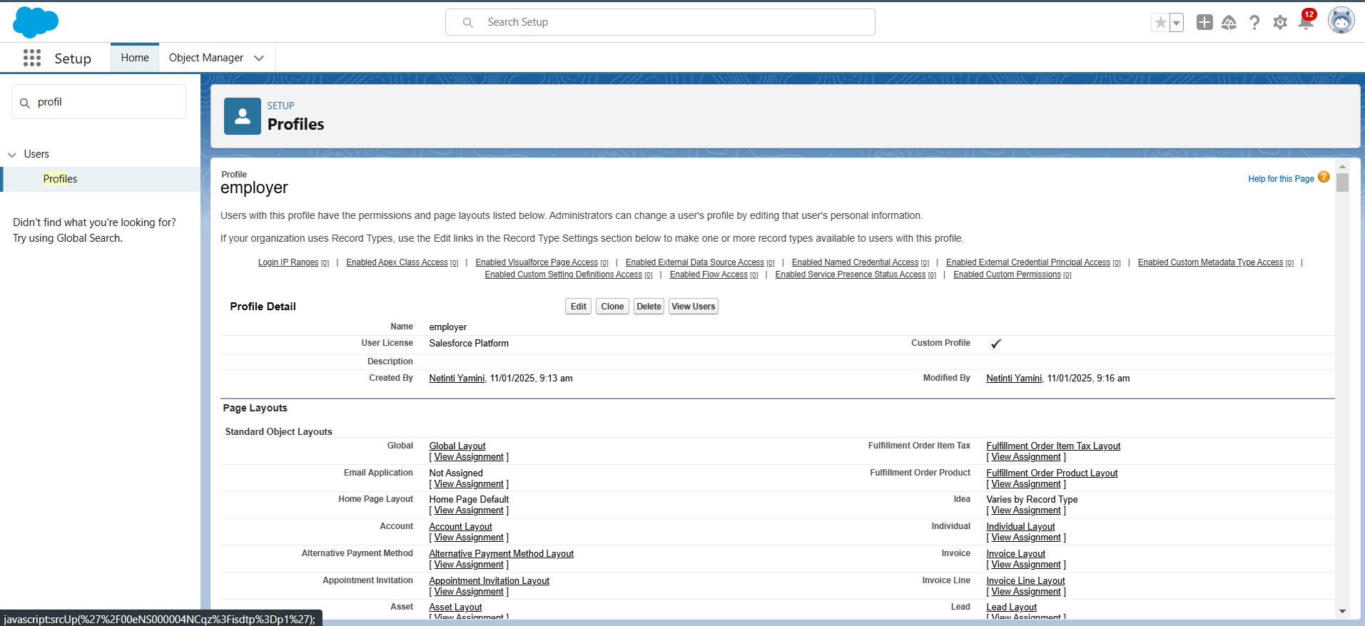

**Worker profile:**

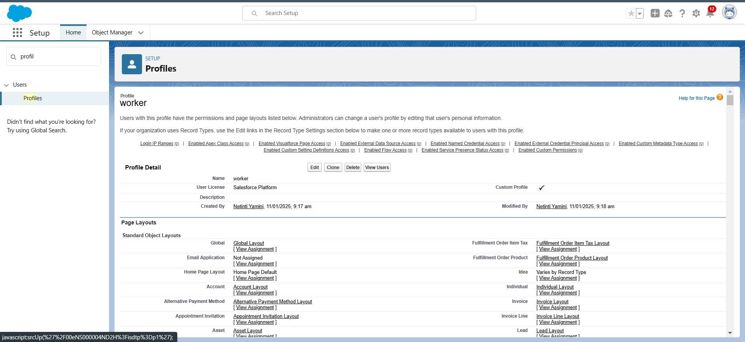

**8. Assign Roles Using Role Hierarchy :**

A role in Salesforce defines a user's visibility access at the record level. Roles may be used to specify the types of access that people in your Salesforce organization can have to data. Simply put, it describes what a user could see within the Salesforce organization.

Created and assigned roles as Owner, Worker to users, which control record visibility based on their hierarchy in the organization.

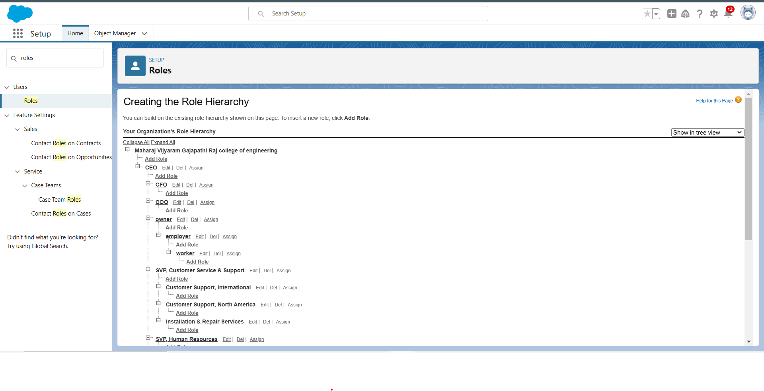

**9.Users :**

A user is anyone who logs in to Salesforce. Users are employees at your company, such as sales reps, managers, and IT specialists, who need access to the company's records. Every user in Salesforce has a user account. The user account identifies the user, and the user account settings determine what features and records the user can access.

created user and creating another users.

**Owner user:**

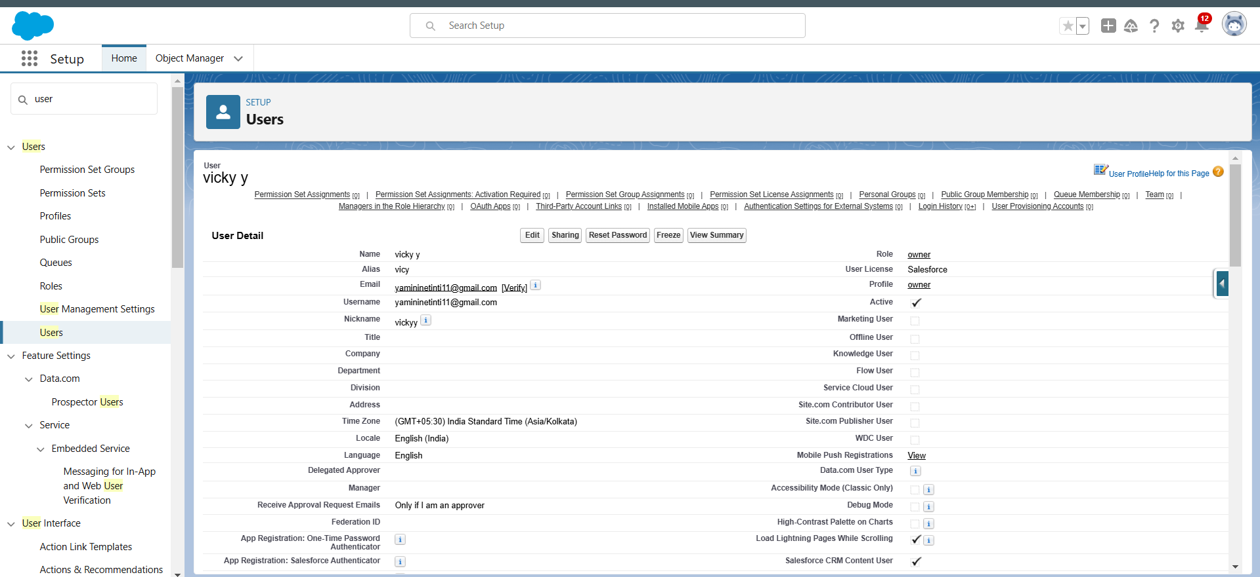

**Employer user:**

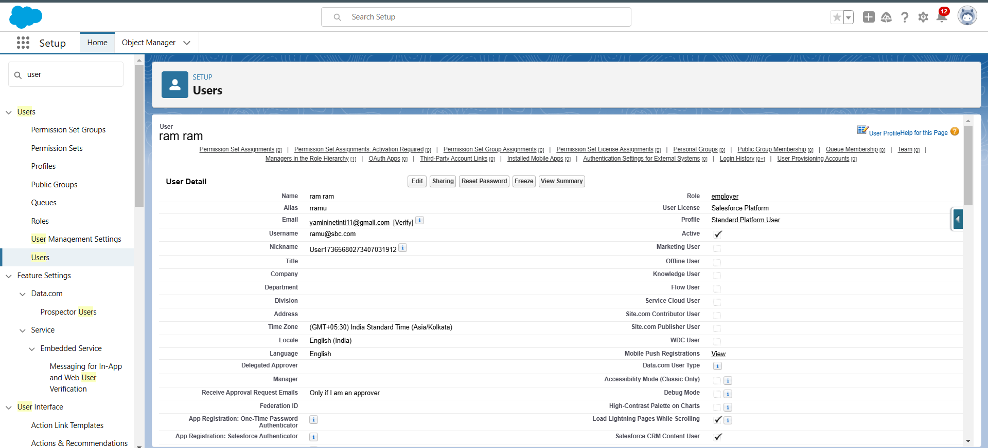

**Worker user:**

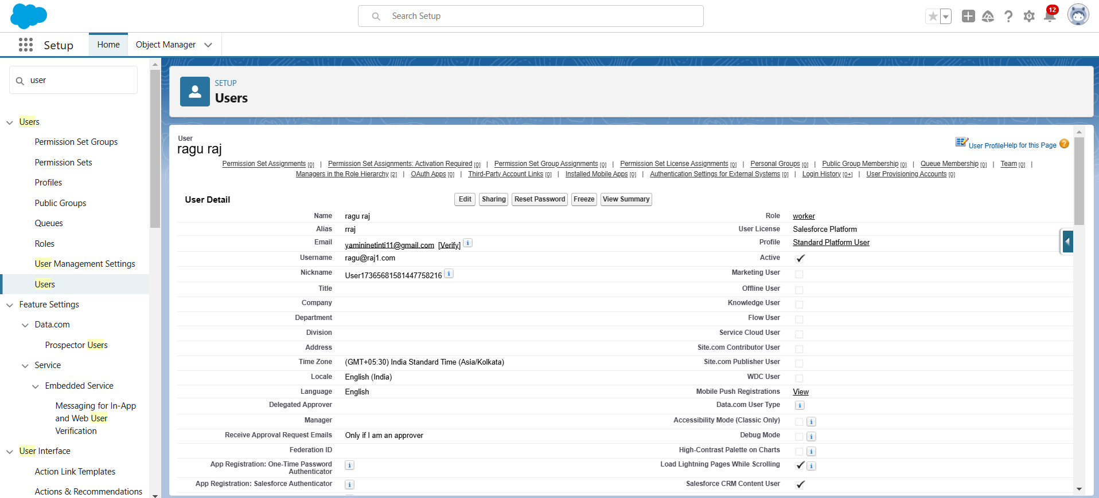

**10. Permission Sets :**

A permission set is a collection of settings and permissions that give users access to various tools and functions. Permission sets extend users’ functional access without changing their profiles and are the recommended way to manage your users’ permissions.

Created permission sets to extend users' access, ensuring that the right roles have the appropriate object permissions.

**Permission sets:**

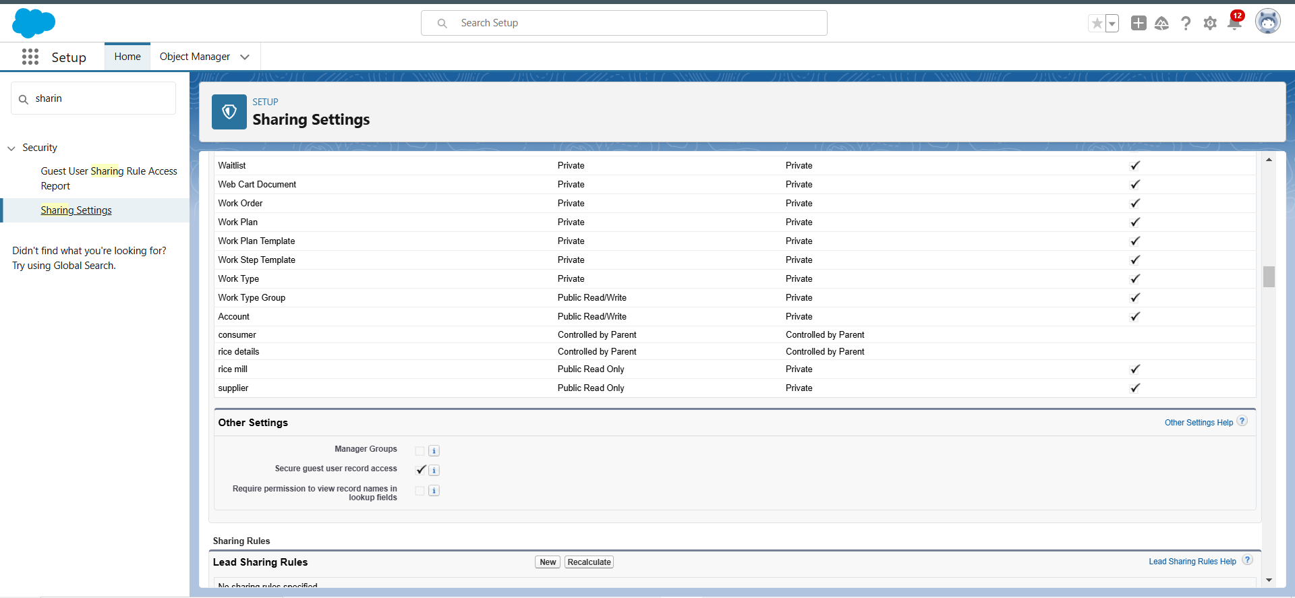

**11. Create Report and Share to owner using folder:**

using Report Builder we used to create reports using grouping of Rows and Columns.

Generated reports for rice distributed or rice sales and share them via folders.

**Generated report:**

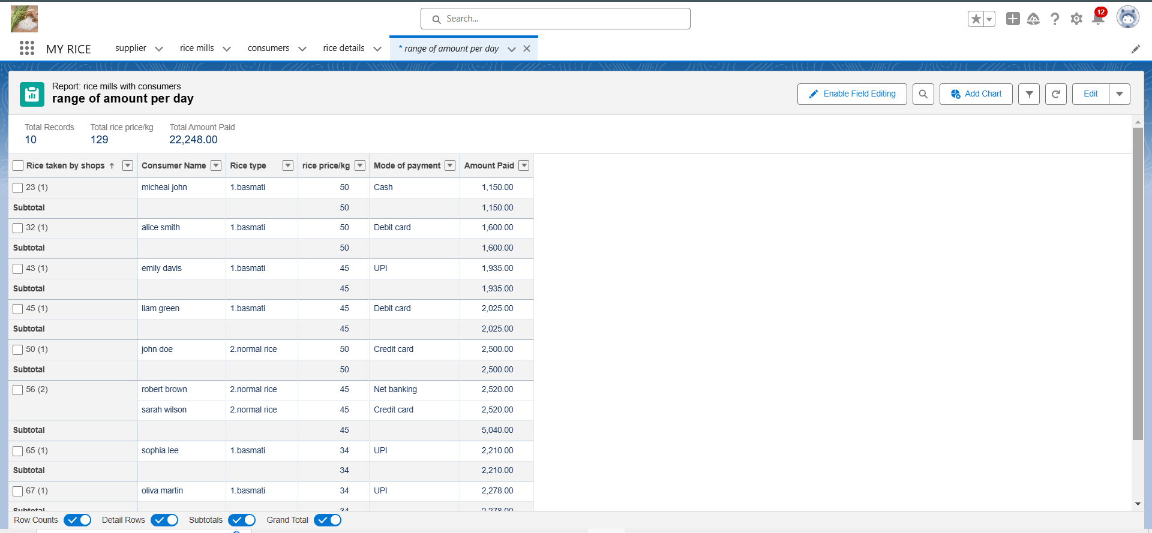

**12.Create Dashboard:**

Dashboards help you visually understand changing business conditions so you can make decisions based on the real-time data you’ve gathered with reports. Use dashboards to help users identify trends, sort out quantities, and measure the impact of their activities. Before building, reading, and sharing dashboards, review these dashboard basics.

Created dashboards for visual representation of key metrics.

**Creation of dashboard:**

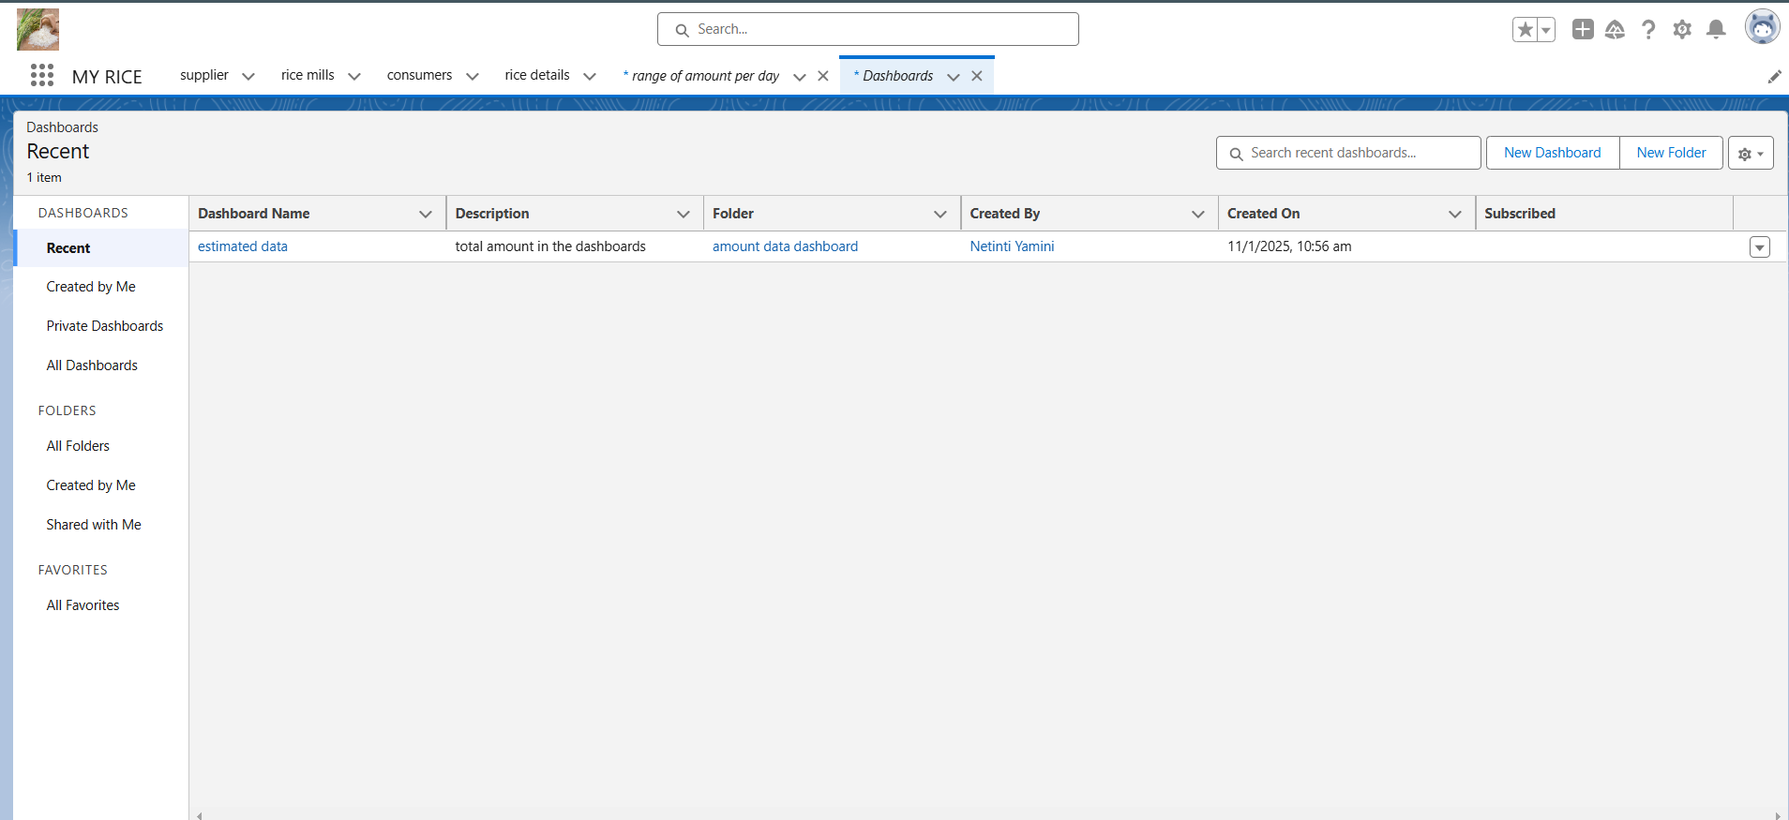

**Dashboards:**

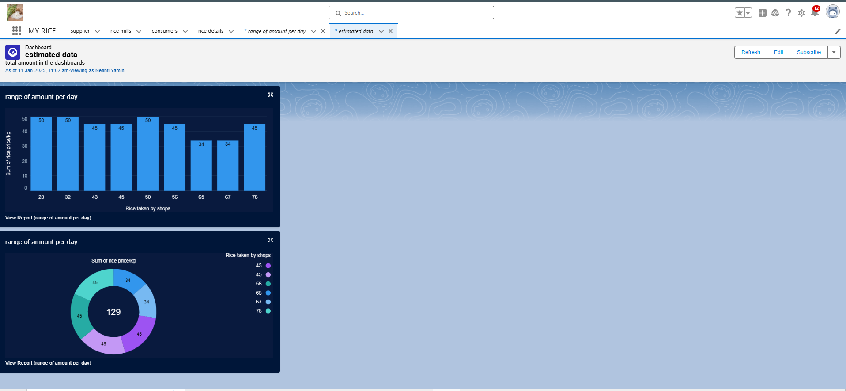

**13. Apex Classes and Triggers :**

Apex is a strongly typed, object-oriented programming language that allows developers to execute flow and transaction control statements on the Lightning platform server in conjunction with calls to the Lightning Platform? API. Using syntax that looks like Java and acts like database stored procedures, Apex enables developers to add business logic to most system events, including button clicks, related record updates, and Visualforce pages. Apex code can be initiated by Web service requests and from triggers on objects.

**Creating an Apex Class(ConsumerRecord):**

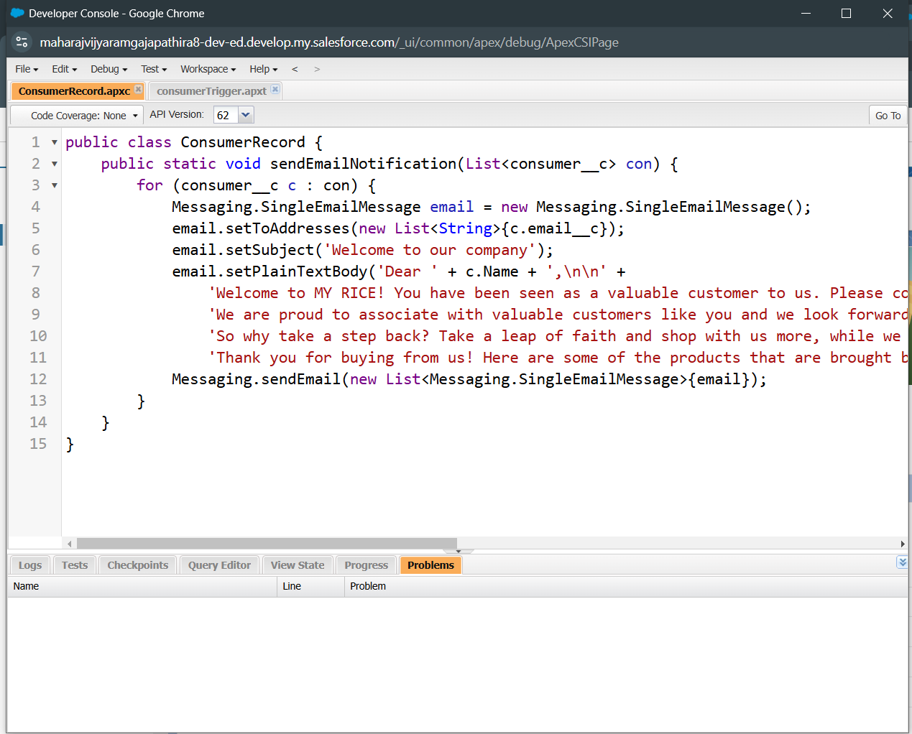

**Creating an Apex Trigger:**

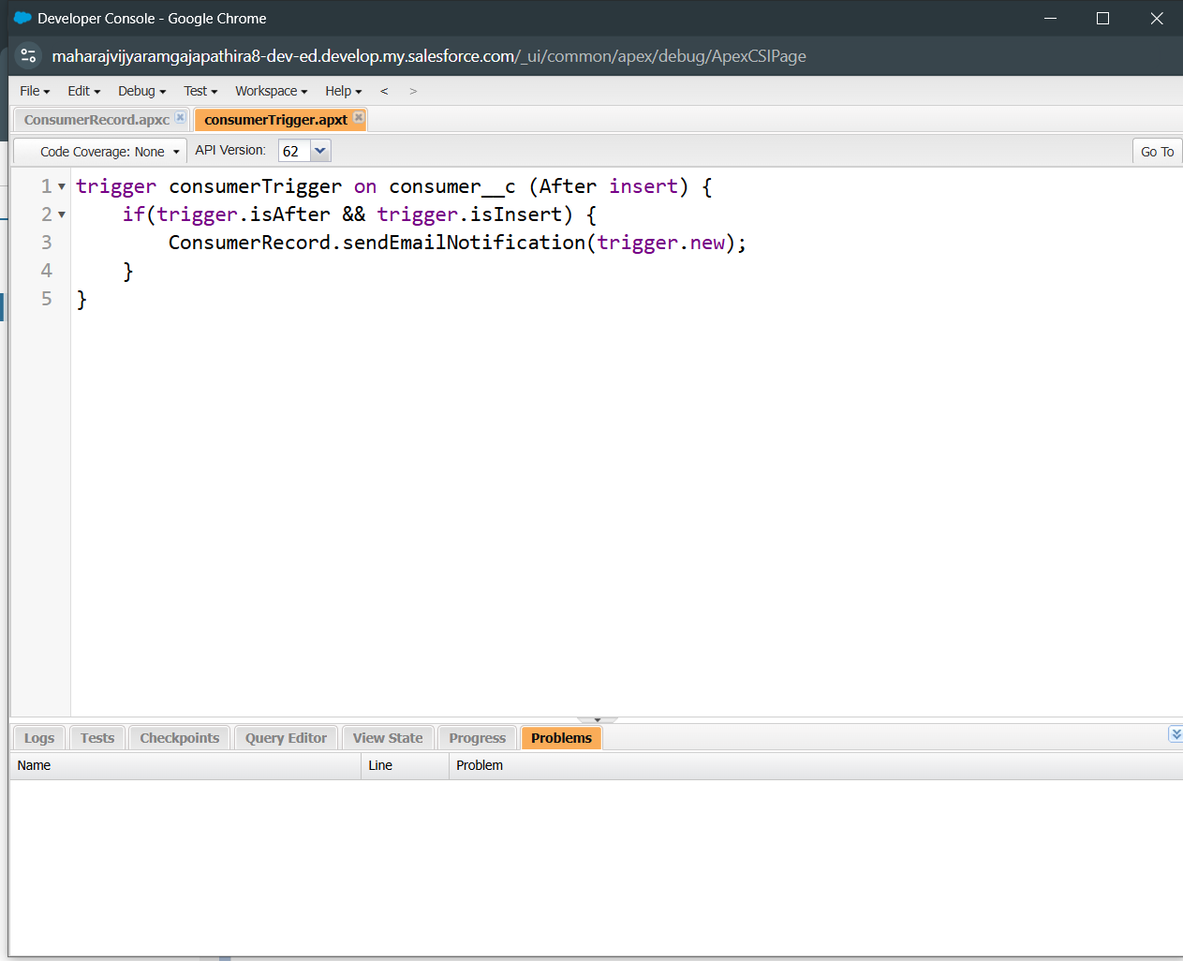

**SUMMARY:**

The CRM application for a wholesale rice mill project on Salesforce involves creating and customizing objects, profiles, roles, and permissions to efficiently manage data like supplier information, rice distribution, and transactions. The project follows a structured process, from setting up a developer account to designing custom objects and fields, and finally, to creating dashboards and reports. Salesforce's tools like Master-Detail relationships, Rollup Summary fields, and Apex triggers help automate processes and enhance decision-making through data analytics. This comprehensive CRM system simplifies business operations, allowing rice mill businesses to maintain and scale their customer relationships effectively.

## 